Chapter 4, Solution 77.

(a) The schematic is shown below. We perform a dc sweep on a current source, I1, connected between terminals a and b. We label the top and bottom of source I1 as 2 and 1 respectively. We plot V(2) – V(1) as shown.

V_{Th} = 4 V [zero intercept]

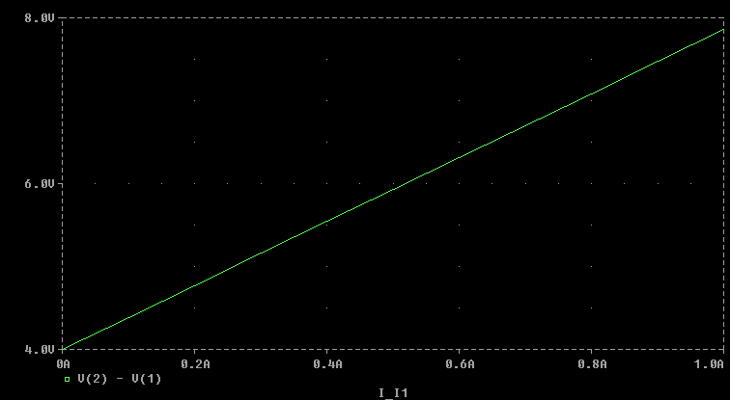
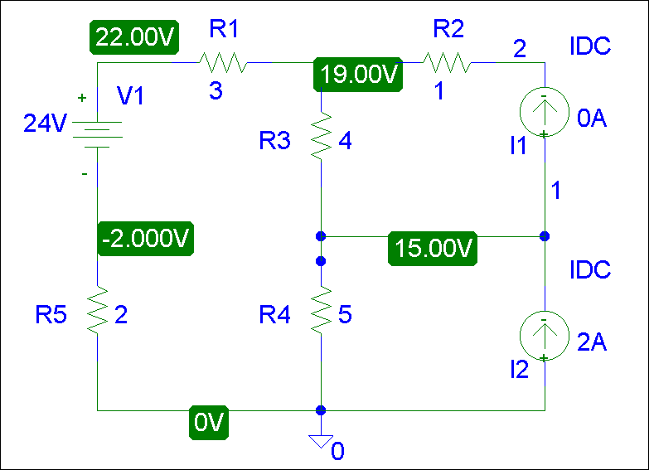
R_{Th} = (7.8 – 4)/1 = 3.8 ohms
- Everything remains the same as in part (a) except that the current source, I1, is connected between terminals b and c as shown below. We perform a dc sweep on I1 and obtain the plot shown below. From the plot, we obtain,

V = 15 V [zero intercept]

R = (18.2 – 15)/1 = 3.2 ohms
